**STOP/INTREPID Teleconference: Wednesday, July 5, 2023, 1:00-2:00 pm**

# Land Acknowledgment:

* Identify the land you are joining us from today ([**https://www.whose.land/en/**](https://www.whose.land/en/))
* Video: [Bringing meaning and purpose to land acknowledgements](https://www.facebook.com/CentreforAddictionandMentalHealth/videos/bringing-meaning-and-purpose-to-land-acknowledgements/759567845184040/)

# TEACH Updates:

* Website: <https://www.nicotinedependenceclinic.com/en/teach>
* Courses: <https://teach.camhx.ca/moodle/> (a number of self-study courses are available)

1. [**Foundational Health Educator Workshop**](https://www.nicotinedependenceclinic.com/en/teach/foundational-health-education-course)

* September 11 & 12, 8:00 am-5:00 pm
* 1001 Queen St. W, Toronto ON, M6J 1H4
* $595 fee (*includes the cost of the required workbook and a lunch on both workshop days*)
* No prerequisites are required; space is limited and registration is on a first come, first served basis
* Requirement for the Certified Tobacco Educator (CTE) credential
* The core competencies of the work﻿shop include:
  1. Health Promotion and Education
  2. Communication (including motivational interviewing)
  3. Educational Interventions
  4. Resource Management
  5. Professional Practice
  6. Program Evaluation
* Register here: [FHE (September 2023) (camhx.ca)](https://teach.camhx.ca/moodle/enrol/index.php?id=98)

General Questions:

**Q: Are there any supports for STOP practitioners during times of stress/loss (e.g., patient/client deaths)?**

**A:** Unfortunately, Intrepid Lab does not have a resource like this available. However, practitioners at the teleconference shared other suggestions:

* [Home | Bereaved Families of Ontario](https://bereavedfamilies.net/).
* Employee Assistance Programs (connected to your respective organization).

**Q: How much time will be spent on MI during the Foundational Health Educator Workshop? Will there be role-playing?**

A: Approximately 4 hours of the workshop will be dedicated to Motivational Interviewing principles, and it will include some elements of role-playing.

**Q: Any suggestions for how to approach smoking interventions for pre-contemplative smokers?**

A: One practitioner shared that they use a “Not Ready to Quit” booklet and created a diagram (see below) for harm reduction ideas for pre-contemplative clients who smoke. You can also share CAMH’s **My Change Plan** booklet (found [here](https://www.nicotinedependenceclinic.com/en/resources-for-providers)), which is a great resource to encourage pre-contemplative smokers to start thinking about their smoking. My Change Plan is also available as an app on Google Play and the Apple Store.

*Resource from practitioner:*

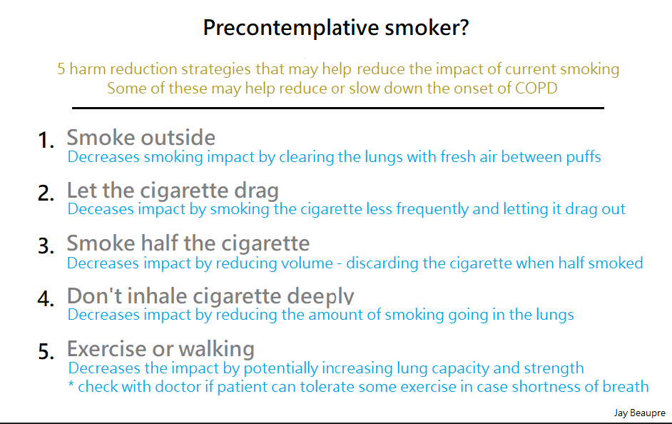

**Q: Are there any smoking cessation support groups (for those trying to stop smoking) available in Toronto currently?**

A: CAMH NDC has group counselling support. Client would need to become an NDC client. They can join by calling Access CAMH (416 535-8501, option 2).

**Q: Does the CAMH Nicotine Dependence Clinic take clients outside of the GTA?**

A: Yes, anyone can join, however, they would have to be able to travel to our CAMH clinic for some appointments.

**Q: Where can we find new CO monitors? Does CAMH have a vendor that services used Pico CO monitors?**

A: Unfortunately, STOP cannot make any recommendations here for specific CO monitors. Please note, Pico CO monitors may no longer meet Health Canada’s MDSP requirements for audit.

News:

1. Health Canada is running a campaign to increase the awareness of available quit smoking supports. To this end, they also wish to reach candidates representing all different racial, socioeconomic, and linguistic backgrounds. They are specifically seeking **French-speaking** candidates aged 35+ who are (criteria repeated in French below):

* A part of a high prevalence (e.g., people who work in trades, LGBTQ+, etc.) and/or equity seeking group (BIPOC);
* Smoke-free for a minimum of 6 months;
* Quit with an approved quit aid (e.g., NRT, bupropion, varenicline, etc.);
* Willing to be interviewed/filmed about their experience quitting smoking and the quit tools/aids they used and found helpful;
* No previous promotional work for the tobacco or vaping industry or for any other smoking/vaping cessation campaign.

**Any patient referrals that you may have that meet the above requirements would be greatly appreciated.** Ideally, these referrals will be made before July 13th, but Health Canada will happily receive any referrals after that date as well.

If you have any questions or know of any patients at your organization who are willing to participate, please let us know so we can connect them with our colleagues at Health Canada.

[Cocreation of a conversational agent to help patients adhere to their varenicline treatment: A study protocol](https://journals.sagepub.com/doi/10.1177/20552076231182807)

### Resources:

**STOP Practitioner Resources Webpage**:

[**https://www.nicotinedependenceclinic.com/en/stop/implementer-resources**](https://www.nicotinedependenceclinic.com/en/stop/implementer-resources)

# STOP Updates:

1. **Self-enroll page updates** ([www.joinstopprogram.ca](http://www.joinstopprogram.ca)) – coming soon
   * Don’t confuse [www.joinstopprogram.ca](http://www.joinstopprogram.ca) (26-week program self-enroll account creation) vs. [www.mystopportal.ca](http://www.mystopportal.ca) (26-week self-enroll survey completion) vs. [www.stoponthenet.ca](http://www.stoponthenet.ca) (8-week SOTN self-enroll)
2. **Upcoming STOP survey update – new questions to be added July 15, 2023**

**Race**

***In our society, people are often described by their race or racial background. Our race may influence the way we are treated by individuals and institutions, and this may affect our health. Which category(ies) best describes you? Select all that apply:***

|  |  |
| --- | --- |
| ○ | First Nations |
| ○ | Inuit |
| ○ | Métis |
| ○ | Black (e.g., African, African Canadian, Afro-Caribbean descent) |
| ○ | Latin American (Hispanic or Latin American descent) |
| ○ | Middle Eastern (e.g., Arab, Persian, West Asian descent [Afghan, Egyptian, Iranian, Kurdish, Lebanese, Turkish, etc.]) |
| ○ | East Asian (e.g., Chinese, Japanese, Korean, Taiwanese descent) |
| ○ | Southeast Asian (e.g., Cambodian, Filipino, Indonesian, Thai, Vietnamese descent) |
| ○ | South Asian (e.g., Bangladeshi, Indian, Indo-Caribbean, Pakistani, Sri Lankan descent) |
| ○ | White (e.g., European descent) |
| ○ | A race category not described above |
| ○ | Do not know |
| ○ | Prefer not to answer |

**Immigrant Status**

***Where were you born?***

|  |  |
| --- | --- |
| ○ | Born in Canada |
| ○ | Born outside Canada |
| ○ | Don’t know / prefer not to answer |

**Transportation**

***In the past 12 months, has lack of transportation kept you from medical appointments, meetings, work, or from getting things needed for daily living? Select all that apply:***

|  |  |
| --- | --- |
| ○ | Yes, it has kept me from medical appointments or getting medicines |
| ○ | Yes, it has kept me from non-medical meetings, appointments, work, or getting things that I need |
| ○ | No |
| ○ | Not applicable, I did not need transportation for these activities in the past 12 months |
| ○ | Do not know |
| ○ | Prefer not to answer |

[Advocates urge collection of race-based data via health cards to address inequities | CP24.com](https://www.cp24.com/news/advocates-urge-collection-of-race-based-data-via-health-cards-to-address-inequities-1.6455663)

# Quote of the day (STOP participant):

*I sweat excessively as I am on the methadone program. So I have lost a few patches when walk I plan to buy some tape just received my ODSP so I will purchase some but as soon as I received this stop smoking kit. I put 1 on the day they arrived. I want to say Thank you for how fast they arrived I am impressed to be honest. I put my quit date as my birthday so I wasn’t expecting these as fast as they came and to be honest probably best. Glad I wasn’t left hanging and you guys reacted so quickly once I reached out  and I want to say Thank you. They are working. I went through almost 2 a day as I said I am on methadone and sweat excessively. I will ask my dr for relief from this and see how this goes. Anyhow thank you once again.*

*Have a great weekend!*

# 2023 teleconference schedule:

|  |  |  |  |
| --- | --- | --- | --- |
| ~~January 11~~ |  | ~~February 1~~ | ~~February 15~~ |
| ~~March 1~~ | ~~March 15~~ | ~~April 5~~ | ~~April 19~~ |
| ~~May 3~~ | ~~May 17~~ | ~~June 7~~ | ~~June 21~~ |
| ~~July 5~~ | ~~July 19 cancelled~~ | **August 2** | ~~August 16 cancelled~~ |
| September 6 | September 20 | October 4 | October 18 |
| November 1 | November 15 | December 6 |  |

Fun Poll:

***If you had a box that could tell you how long you had left to live, would you open it (from The Measure, Nikki Erlick)?***

*Yes 24/53 = 45%*

***No 28/53 = 53%***

*Don’t know / prefer not to answer 1/53 = 2%*

# Attendance:

Anishwabe Mushkiki AHAC Algoma PHU

Algonquin FHT

Athens FHT

Blue Sky FHT

Brockton and Area FHT

Burk’s Falls FHT

Byward FHT

Carea CHC

CCCKL CHC

Central Lambton FHT

Centretown CHC

Chatham-Kent FHT

Chatham-Kent PHU

CHIRS AMHA

City of Lakes FHT

CMHA Algoma

CMHA Huron Perth

CMHA Ottawa

ConnectWell CHC

Dufferin Area FHT

Emery Keelesdale NPLC

Englehart and District FHT

Fort William FHT

Four Villages CHC

Georgian Bay FHT

Grand Bend Area CHC

Grandview FHT

Great Northern FHT

Grey Bruce PHU

Guelph FHT

Haldimand FHT

Hamilton PHU

Hamilton-Niagara CHC

Health for All FHT

HKPR PHU

Homewood Community AA

Humber River FHT

Huron Perth PHU

Huronia NPLC

Jane Finch FHT

KFL&A PHU

Kingston CHC

Kirkland District FHT

Leeds and Grenville FHT

Leeds and Grenville PHU

Lower Outaouais FHT

Maitland Valley FHT

M’Chigeeng Health Services

Middlesex-London PHU

Niagara Falls CHC

Niagara North FHT

Niagara Region PHU

North Durham FHT

North Muskoka NPLC

North York FHT

Northumberland FHT

Northwestern PHU

Owen Sound FHT

Peterborough FHT

Prince Edward FHT

Queen’s Square FHT

Rideau CHC

Scarborough A FHT

Seaway Valley CHC

Sherbourne FHT

Simcoe Muskoka PHU

Six Nations AHAC

Somerset West CHC

South Georgian Bay CHC

St. Michael’s Homes

Stratford FHT

Sudbury PHU

Summerville FHT

Superior FHT

Taddle Creek FHT

Temagami FHT

Thames Valley FHT

Thunder Bay PHU

Timiskaming PHU

Twin Bridges NPLC

Two Rivers FHT

Upper Canada FHT

West Champlain FHT

West Nipissing CHC

Windsor Essex PHU

Women’s College Hospital FHT